*\*&---------------------------------------------------------------------\**  
*\*& Module Pool       ZNYN_MODULE_POOL_17*  
*\*&*  
*\*&---------------------------------------------------------------------\**  
*\*&*  
*\*&*  
*\*&---------------------------------------------------------------------\**  
PROGRAM ZNYN_MODULE_POOL_17.  
  
TABLES ZNYN_DEPT1.  
DATA : IT_TAB TYPE STANDARD TABLE OF ZNYN_DEPT1,  
       WA_TAB TYPE ZNYN_DEPT1.

PROCESS BEFORE OUTPUT.  
 MODULE STATUS_0100.  
 MODULE hide_functions.  
  
PROCESS AFTER INPUT.  
 MODULE USER_COMMAND_0100.

*\*----------------------------------------------------------------------\**  
*\*\*\*INCLUDE ZNYN_MODULE_POOL_17_STATUS_O01.*  
*\*----------------------------------------------------------------------\**  
*\*&---------------------------------------------------------------------\**  
*\*&      Module  STATUS_0100  OUTPUT*  
*\*&---------------------------------------------------------------------\**  
*\*       text*  
*\*----------------------------------------------------------------------\**  
MODULE STATUS_0100 OUTPUT.  
*\*  SET PF-STATUS 'xxxxxxxx'.*  
*\*  SET TITLEBAR 'xxx'.*  
SET PF-STATUS SPACE.  
ENDMODULE.

*\*----------------------------------------------------------------------\**  
*\*\*\*INCLUDE ZNYN_MODULE_POOL_17_HIDE_FUO01.*  
*\*----------------------------------------------------------------------\**  
*\*&---------------------------------------------------------------------\**  
*\*&      Module  HIDE_FUNCTIONS  OUTPUT*  
*\*&---------------------------------------------------------------------\**  
*\*       text*  
*\*----------------------------------------------------------------------\**  
MODULE HIDE_FUNCTIONS OUTPUT.  
  LOOP AT SCREEN.  
    CASE SY-UCOMM.  
      WHEN 'INSERT'.  
        IF SCREEN-GROUP1 EQ 'G2' OR SCREEN-GROUP1 EQ 'G3'.  
          SCREEN-INPUT = '0'.  
*\*//SCREEN-INPUT = '1'.*  
              *"  To be greyed  out or not i.e. Can /cannot take input.*  
          MODIFY SCREEN.  
        ENDIF.  
  
      WHEN 'MODIFY'.  
        IF SCREEN-GROUP1 EQ 'G3' OR SCREEN-GROUP1 EQ 'G1'.  
          SCREEN-ACTIVE = '0'.  
*\*Will appear/disappear from screen.*  
          MODIFY SCREEN.  
        ENDIF.  
    ENDCASE.  
  ENDLOOP.  
ENDMODULE.

*\*----------------------------------------------------------------------\**  
*\*\*\*INCLUDE ZNYN_MODULE_POOL_17_USER_COI01.*  
*\*----------------------------------------------------------------------\**  
*\*&---------------------------------------------------------------------\**  
*\*&      Module  USER_COMMAND_0100  INPUT*  
*\*&---------------------------------------------------------------------\**  
*\*       text*  
*\*----------------------------------------------------------------------\**  
MODULE USER_COMMAND_0100 INPUT.  
  CASE SY-UCOMM.  
    WHEN 'INSERT'.  
      INSERT INTO ZNYN_DEPT1 VALUES WA_TAB.  
      IF SY-SUBRC EQ 0.  
        MESSAGE 'DEPARTMENT TABLE HAS BEEN INSERTED SUCCESSFULLY' TYPE 'I'.  
      ELSE.  
        MESSAGE 'DEPARTMENT TABLE HAS NOT UPDATED' TYPE 'I'.  
      ENDIF.  
  
*\* MODIFY*  
    WHEN 'MODIFY'.  
      UPDATE ZNYN_DEPT1 FROM  WA_TAB.  
      IF SY-SUBRC EQ 0.  
        MESSAGE  'DEPARTMENT TABLE HAS BEEN UPDATED SUCCESSFULLY' TYPE 'I'.  
      ELSE.  
        MESSAGE  'DEPARTMENT HAS NOT UPDATED' TYPE 'I'.  
      ENDIF.  
  
*\*DELETE.*  
    WHEN 'DELETE'.  
      DELETE FROM ZNYN_DEPT1 WHERE DEPTNO = WA_TAB-DEPTNO.  
      IF SY-SUBRC EQ 0.  
        MESSAGE  'DEPARTMENT TABLE HAS BEEN DELETED SUCCESSFULLY' TYPE 'I'.  
      ELSE.  
        MESSAGE   'DEPARTMENT HAS NOT DELETED' TYPE 'I'.  
      ENDIF.  
  
    WHEN 'CLEAR'. *"clears the data from the field*  
      CLEAR WA_TAB.  
  
    WHEN 'EXIT'.  
      LEAVE PROGRAM.  
  ENDCASE.  
ENDMODULE.

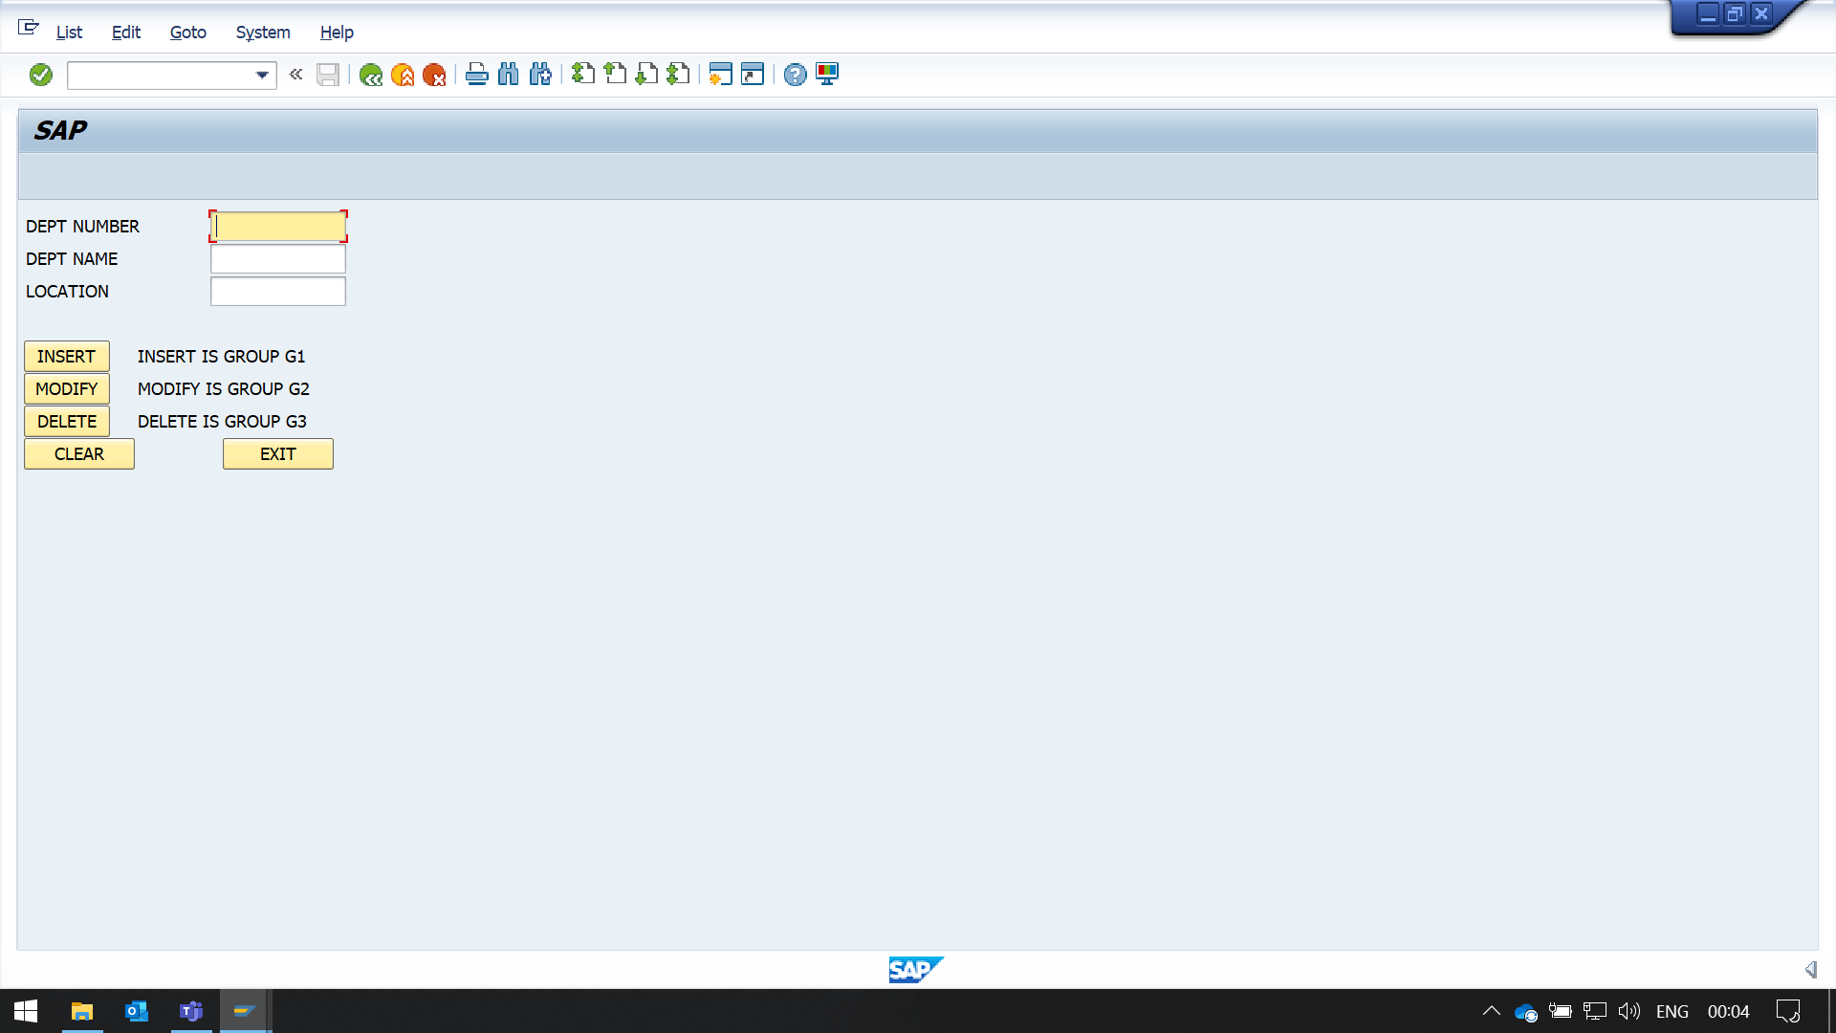

INSERT is group G1

MoDIFY is group G2

DELETE is group G3

